**Problem 1.**

Section 1.1, Exercise 1.

1. n is given
2. i = 0
3. sum = 0
4. i = i + 1
5. sum = sum + 1/(1+i)^2
6. Repeat 4 and 5 for i <= n

**Problem 2.**

Section 1.1, Exercise 3.

1. Input is s for the sequence of distinct numbers and n for index
2. i = 1
3. smallest_element = i’th term in sequence
4. i = i + 1
5. if i’th term in sequence < smallest_element let smallest_element = i’th term in sequence
6. while i<n repeat lines 4 and 5

**Problem 3.**

Section 1.3, Exercise 8.

0110000011000000

**Problem 4.**

Section 1.3, Exercise 11.

Get two’s complement of A3F2  
 FFFF – A3F2 = 5C0D  
 5C0D + 1 = 5C0E

5C0E as a decimal = 16^0 * 14 + 16^2 * 12 + 16^3 * 5  
 = 23566

Therefore, signed Hex A3F2 = Decimal -23566

**Problem 5.**

Section 1.3, Exercise 23.

Sign/exponent/mantissa

-ve/40+127/0.75

1/10100111/11000000000000000000000

1 10100111 11000000000000000000000

**Problem 6.**

Section 2.4, Exercise 1.

“7

5

3

1”

**Problem 7.**

Section 2.4, Exercise 3.

“-1”

**Problem 8.**

Install DEV-C++ , xcode, or MS Visual Studio.

Run the suggested sample programs.

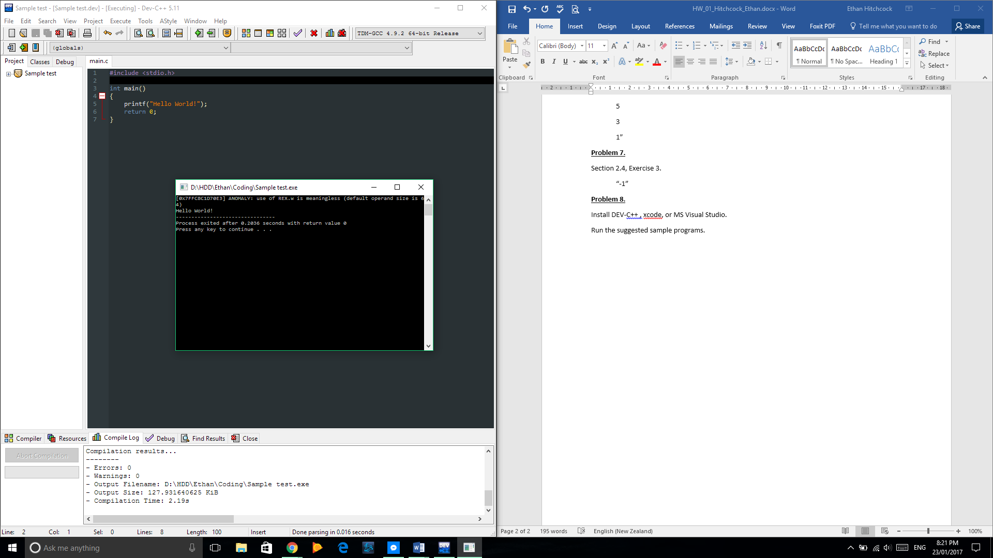

Tested IDE with simple Hello World program.